**1. Dependency in POM.xml**

*<!--Dependency for applying validation on DTO level-->* <dependency>  
 <groupId>org.springframework.boot</groupId>  
 <artifactId>spring-boot-starter-validation</artifactId>  
 </dependency>

**2. Put Validation on DTO fields**

@Data  
public class CustomerDto {  
 @NotEmpty(message = "Name can't be null or empty")  
 @Size(min = 5, max = 30, message = "The length of the customer name should be between 5 to 30")  
 private String name;  
 @NotEmpty(message = "Email can't be null or empty")  
 @Email(message = "Email address should be a valid value")  
 private String email;  
 @NotEmpty(message = "Mobile number can't be null or empty")  
 @Pattern(regexp = "(^|[0-9]{10})", message = "Mobile number must be of 10 digit")  
 private String mobileNumber;  
 private AccountsDto accountsDto;  
}

**3. Need to mark controller as @Validated**

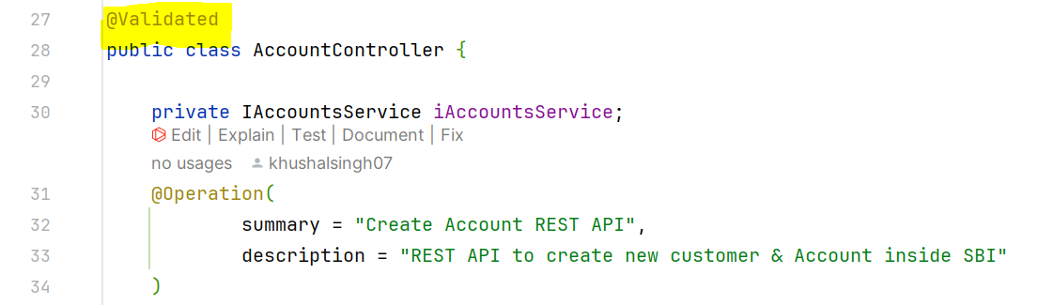

**4. Need to validate RequestBody and Request Param**

(a). Request Body: Put @Valid before @RequestBody

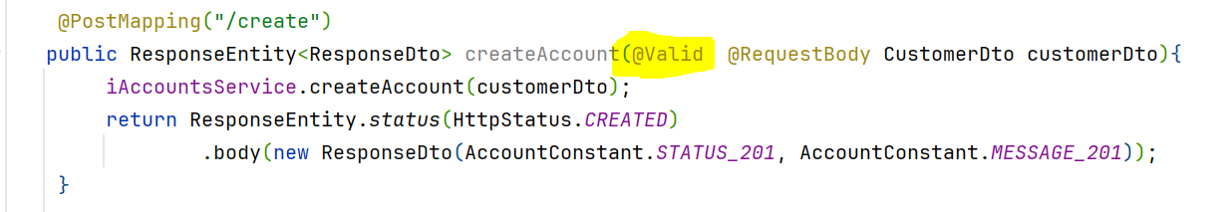

(b). Request Param: Put validation code after @RequestParam attribute

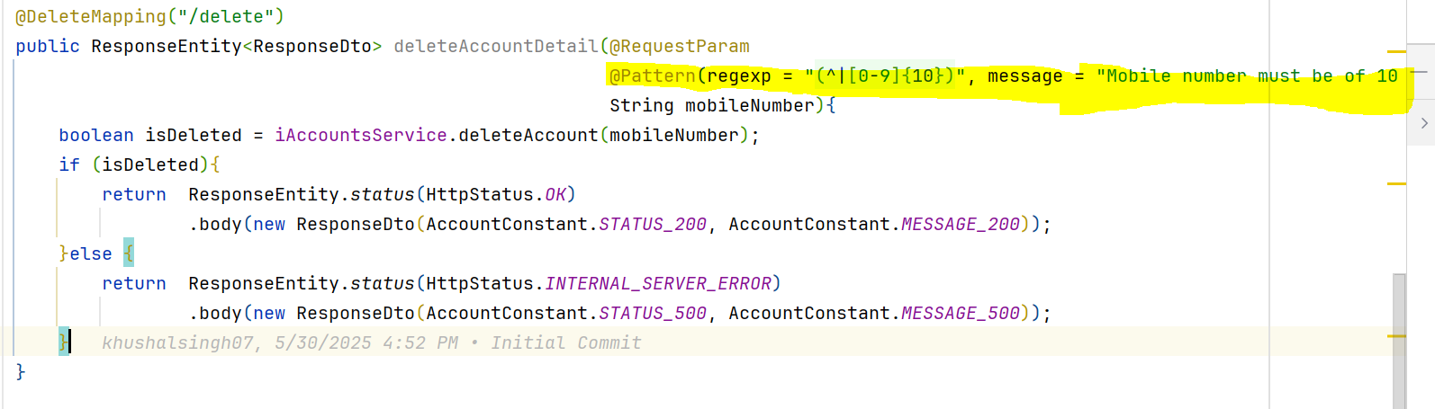

**5. Return the error message in error response**

(a). Extend ResponseEntityExceptionHandler in GlobalExceptionHandler class and override   
 handleMethodArgumentNotValid() in the class

